Vanijya – Commerce Society
Annual Report 2017-18
Teacher in charge : Dr. Monica Aggarwal

- Group discussion(September 26, 2017)
Vanijya-The Commerce Society Of Aryabhatta college organised a Group discussion on September 26, 2017 for the students of commerce course so as to imbibe in the debating skills and overcome their fear of public speaking’

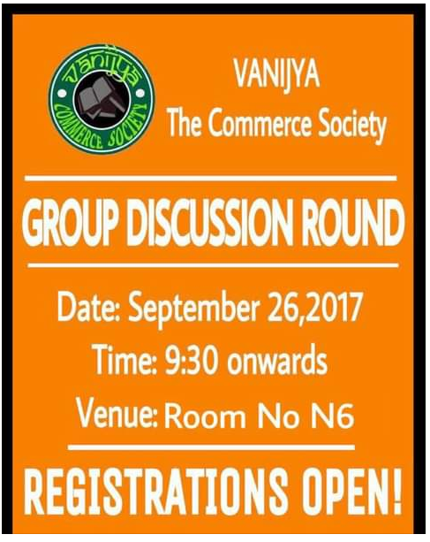

- Seminar – Importance of group discussion (January 28, 2018)

Vanijya-The Commerce Society Of Aryabhatta college organised a seminar on importance of Group Discussion (GD) on January 25, 2018. Spokesperson for the session was Mr. Kumar Abhishek Pathak and Mr Vijay Shukla from IMS.

Mr Kumar described what must be done after cat. After scoring a good percentile in cat exam you need to clear group discussion and personal interview to secure a seat in the top rated colleges. GD which is considered as an elimination round confronts only intelligent candidates .There is a minor difference between a Gd and a Debate and a lot more was discussed in the seminar.

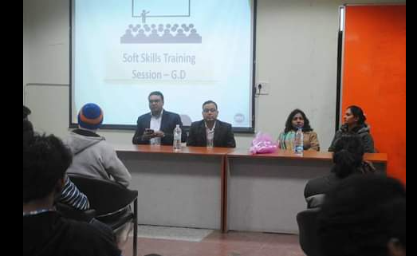

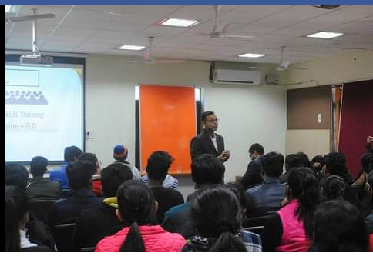

- Annual fest – Emblazors ( February 6, 2018)

Vanijya – The commerce society presents its annual commerce fest – “EMBLAZORS” on February 2, 2018.
This is the Third recension of commerce fest. This fest consisted of Five Major Events:
-BID 2 WIN Aisa Mauka aur kaha megal
-BUILD AND TRADE - [Think Beyond the Décor]
-QUIZICAL SUSPECTS - (Where the smart answer won't get you)
-CAN YOU ESCAPE [Think Like Sherlock]
-TREASURE HUNT – (Clear vision holds the key)
The event had participants from various college across universities.

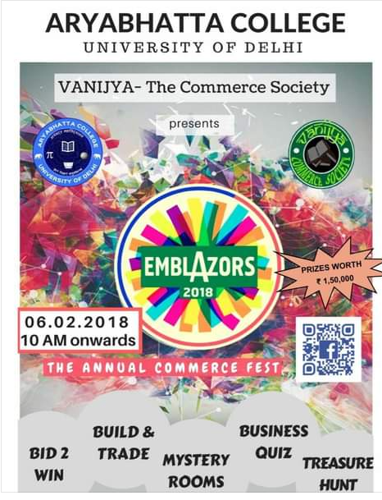

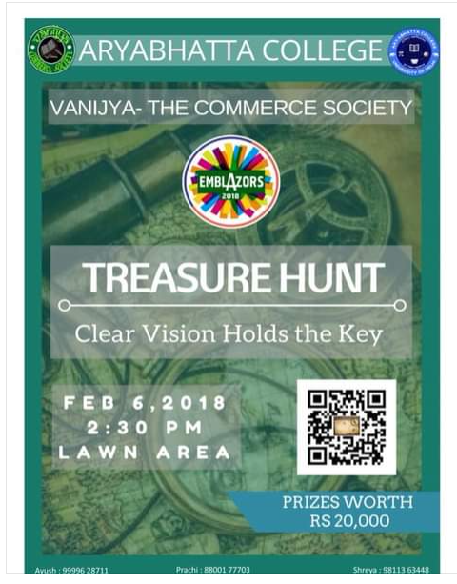

- Scholarship test (February 17, 2018)

Vanijya – The commerce society organised a ‘scholarship test” for the students aiming for MBA in collaboration with IMS institute. The test will enable you all to understand where you are and where you want to be. All the students who score a 75% and above would get a benefit of concessional CAT coaching.

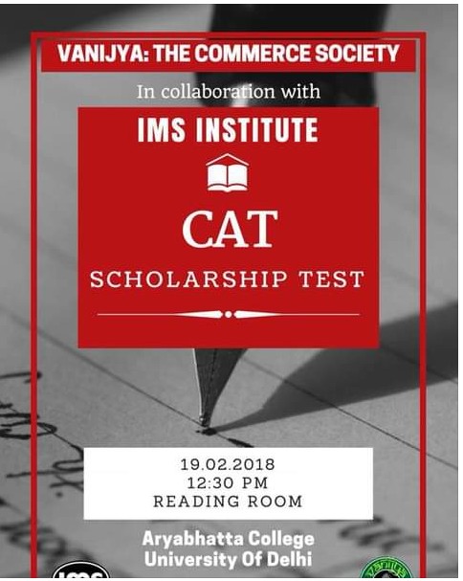

- Seminar – How to build your CV (April 4, 2018)

A seminar on CV writing skills was organised by Vanijya – The commerce society on April 4, 2018. Eminent speaker of the session was Mr. Dhrubajyoti Banik from IMS. He gave very valuable tips on how to upgrade your CV and have a competitive edge over others.

